**Children's Faith Formation**

**To register for Elementary Faith Formation classes:** [**https://giving.parishsoft.com/App/Form/a5861334-798b-41be-87e6-d8a38433bbf6**](https://giving.parishsoft.com/App/Form/a5861334-798b-41be-87e6-d8a38433bbf6)

Elementary Faith Formation classes are offered for Kindergarten through Fifth Grades and begin August 24, 2025. Classes take place on Sundays, 10:30-11:30 AM in the St. Bridget Elementary School. We are using the Loyola Press *Finding God* curriculum for the 2025-26 year.

**2025-2026 Elementary Faith Formation Calendar:**[**CALENDAR**](https://saintbridgetchurch.org/portals/stbridg/CMAdmin/Faith%20Formation%20Calendar%202024-25_1.pdf)

**Elementary Faith Formation Parent Handbook:**[**HANDBOOK**](https://saintbridgetchurch.org/portals/stbridg/CMAdmin/Parent%20Handbook%20PDF%20layout%202%2024-25_1.pdf)

**Loyola Press *Finding God* Parent Resources:**[**AT-HOME RESOURCES**](https://www.loyolapress.com/faith-formation/finding-god/finding-god-2021/parents-and-students/)

**Sacramental Preparation: First Reconciliation and First Holy Communion**

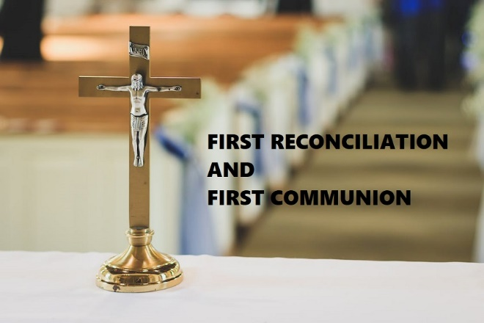

**To register for Sacramental Preparation:** [**https://giving.parishsoft.com/App/Form/3afb62bd-9a7d-437c-9ddf-0ea8619d6192**](https://giving.parishsoft.com/App/Form/3afb62bd-9a7d-437c-9ddf-0ea8619d6192)

Preparation for First Reconciliation and First Holy Communion is open to all St. Bridget children who are in the 2nd grade. All baptized children must prepare for First Reconciliation before preparation for First Holy Communion.

Sacramental preparation is a combination of at-home reading & activities and in-person parish sessions. We are using the Pflaum *Together in Jesus First Reconciliation* and *First Eucharist* series. Children must also be enrolled in either the parish Faith Formation classes or attend a Catholic school during their preparation.

In addition, families should be registered members of the St. Bridget Parish. You can register as a parishioner [HERE](https://docs.google.com/forms/d/e/1FAIpQLScQxUu-ts01sPCX0ndnZ3ot9Ibobo6VNFU5ncgD3Jv0jOqxSw/viewform?c=0&w=1).

**Pflaum *Together in Jesus* curriculum:** [**SACRAMENTAL PREPARATION – Pflaum Publishing Group**](https://www.pflaum.com/sacraments/)

***First Reconciliation* and *First Eucharist* Bonus Resources:** [**BONUS RESOURCES – Pflaum Publishing Group**](https://www.pflaum.com/sacraments/bonus-resources/#1536617605578-4ec000a0-71f5)

**A typical year of Sacramental Preparation includes the following:**

**First Reconciliation**

* At-Home *First Reconciliation* book to be completed
* One Parent session focused on Reconciliation – Sunday, September 7, 2025 from 10:30 – 11:30 AM in St. Bridget School Mother Presentation Hall
* First Reconciliation Retreat for parent and child(ren) choose either Saturday, January 10or 24, 2026, 9:30 – 11:30 AM
* Celebration of First Reconciliation – choose either Saturday, February 14 or 28, 2026, 10:00 – 11:30 AM

**First Eucharist**

* At-Home *First Eucharist* book to be completed
* One Parent session focused on the Eucharist – Sunday, March 1, 2026 from 10:30 – 11:30 AM in St. Bridget School Mother Presentation Hall
* First Communion Retreat and rehearsal for parent and child(ren) choose either Saturday April 18 or 25, 2026, 9:30 – 11:30 AM
* Celebration of First Holy Communion – choose either May 2, 3, 9 or 10, 2026. Sign ups to begin in December.